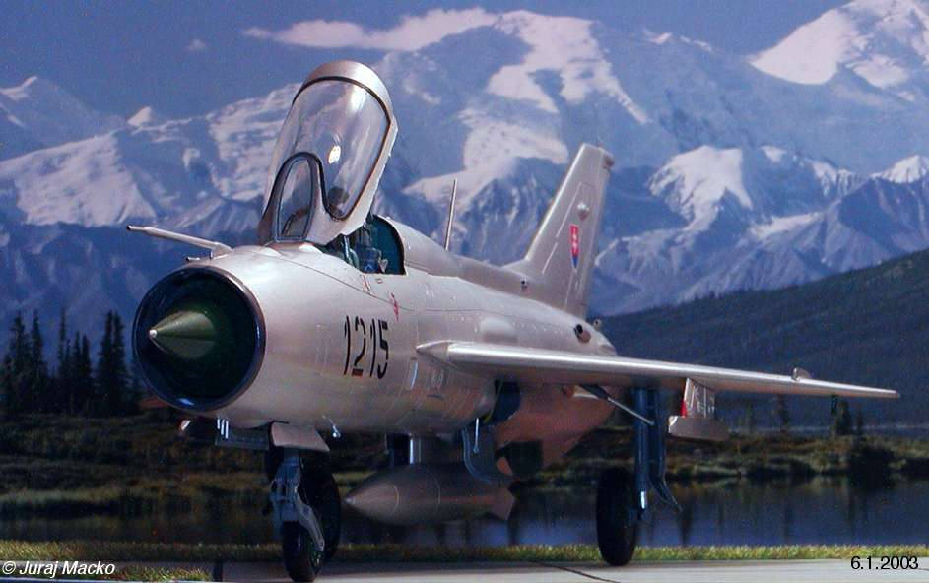
Happy New Year to all fans of modeling!

Today I want present You my latest finished model – 1/48 Mig 21 PF by Academy.

History.
All it started approximately 30 years ago, when I saw every day big silver birds in the sky above as a six year old boy.
That was Migs 21 F and PF, and those aircrafts with specific delta wings was for me and not only for me the synonym for the world „fighter“.
In the last year I did a complete research of usage Migs 21 of all versions in Czechoslovakian airforce, and after the separating of former Czechoslovakia in Slovak Air Forces.
So when in the april 2002 hit me the oportunity of photographing in the Slovak Army Historic Museum in Trencin,
which is closed for public and have status of archive, I packed up my digital camera and started a half year work on documenting and cataloging the materials about this nice delta wing bird with codename – FISHBED..
From this point was only little step to collecting complete Fishbed line in CZ and SK forces – that was
F13, PF, PFM, MF, R and double seaters – U, UM and final version of US. Some of them are in 1/72 scale, some in quarter scale. The first of them that I decided build in „Slovak“ colors was the 1/48 PF of Academy.

Kit.
About kit was written many reviews. So, kit is beautyfully molded in grey styrene with nice clear parts.
I think that very good represent the PF version. when I look on images of real aircrafts and compared the parts with drawings.
I replaced the interior with nice Pavla models one, sprayed it with Agama 35, which is the real color for Mig interior green. New is gunsight with cabling. All other construction was quite easy without problems, and I only added some important details on cabine, landing gears and in the wheel wells, and made a new rotor of turbine last gear. The afterburner from kit wasn’t used.

Painting.
I decide make a collection of non weathered Migs, and in order to this I used basic Humbrol 1, and then whole airplane was sprayed with Revell 99 Aluminium. After 30 minutes I slightly started buffing of this coat, but really only fine with cotton wool. After 24 hours on shelf for perfect drying I masked selected panels in accordance with photos with Tamiya tape and oversprayed non masked panels with Model Master Metalizer Buff. Aluminium. I buffed it without unmasking after 10 minutes.
Next day I removed masking and overcoat whole plane with acrylic floor wax (no, not Future, not Kleer, not Clear – Sidolux is our name, hehehe). It makes hard semigloss film on the alu-silver plates as I saw it on real planes.
For tyres and cockpit covering was used Eduard express masks – great.

Decals.
I used Propagteam Slovak insignia, other decals are self maded – number 1215 was scanned, drawed again in Adobe Illustrator, scaled, printed onto Revell mask sheet on inkjet printer, cutted with sharp Xacto knife, then sprayed over this template to decal paper, overpainted with lacquer and – as easy – applied as usually ☺. Other small decals was painted with thin brush.

Conclusions.
Conclusions? See on the images. Are better than much more words. What can You see? I mean that quite good replica of Mig 21 PF, usually called Acrobatic Mig by his pilots. I can recommend this kit to everyone, because is good engineered and with some aftermarket addditions will be really perfect element of every „ Migography “ .
As many of You saw in my article Ka-25 there, I am true masochist ☺. Next I want build Academy’s Mig 21 MF.
This will be another café ☺, because this kit represent „bis“ version. So, I have prepared new corrected spin, new interior, new type of Slovak decals, drawings for correcting scribing on wings…and You will see that it CAN be the MF anyway!!!☺

Enjoy the images!!

Juro

