„A fallen hero”
Me-109G-6 Romanian Royal Aeronautics
Revell 1/32
By Florin “Scorpio”Silaghi

First one to start with a brief biography of the man who was the ace of the Romanian Royal Aeronautics, as long as Romania was allied with Germany in the Second World War. This model I made ​​in his memory.

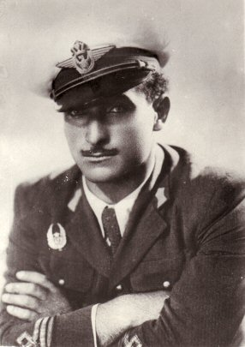

Alexandru "Alecu" Şerbănescu
17 May 1918 – 18 August 1944
Alexandru "Alecu" Şerbănescu (May 17, 1912, Coloneşti, Olt County- August 18, 1944, Ruşavăţ, Buzău County) was a leading Romanian fighter pilot and flying ace in World War II. In the spring of 1942 he was assigned as a pilot to the 7th Fighter Group, which fought with the German forces against the Soviet Union on the Eastern Front, including Stalingrad. He flew mostly IAR-80 and Messerchmitt Bf-109 fighters.
He graduated from the Military College at Târgovişte and the Infantry Officers School at Sibiu in 1933 and was soon appointed the commander of the 3rd Mountain Troops battalion, located at Braşov. In 1942, he joined the Air Force Flight School in Ghimbav and became soon a fighter pilot within the 7th Fighter Group.
The 7th Fighter Group was detached in 1942 to the Stalingrad front. Şerbănescu distinguished himself in the fierce battles during the retreat from the airfields around Stalingrad. When Soviets broke the German and Romanian defenses in November 1942 and approached the Romanian airfield where the 7th Fighter Group was stationed, Şerbănescu successfully organized the defense of the airbase against the Allied forces, helped by his infantry experience. He had at his disposal only two anti-aircraft guns (one Rheinmetall 37mm and one 75mm Vickers-Reşiţa gun), the 20mm guns on the Bf-109Es and a company of ill-equipped and trained soldiers. The Romanians' camouflaged positions and well-led defense stopped the Soviet tanks attacking the airfield for two days. The Bf 109's 20 mm guns were used as antitank weapons on the ground (by lifting the airplane's tail on barrels), this being a unique case of airplane-tank duel. On November 23, 1942 the Romanians evacuated eight Bf-109E (another 3 were lost while they tried to take off under fire). Each airplane carried two or three people in the cockpit. After this, what remained of Şerbănescu's unit was stationed on the Morozovskaya airfield and was soon withdrawn to Romania for rest and recuperation.
On March 29, 1943, Şerbănescu was appointed commander of the 57th Fighter Squadron, equipped with the new Messerschmitt Bf-109G, and promoted to the rank of Captain. Between June and August 1943 he shot down 28 Allied aircraft, and received the highest Romanian military decoration, Order of Michael the Brave, 3rd Class. On October 23, the 9th Fighter Group replaced the battle-exhausted 7th Fighter Group, but Şerbănescu and the other aces remained. He kept fighting and shooting down airplanes of the Allies and, as a result, he was named the Group's commander on February 13, 1944. In May 1944 the Red Army entered Romania and occupied northern Bassarabia and northern Moldavia, but they were stopped after some fierce fighting, in which the pilots also played a very important role. On June 11, Şerbănescu shot down his first USAAF aircraft, a B-17 Flying Fortress, his 45th victory. This was followed by two Allied P-51 Mustangs shot down on July 31 and on August 4 respectively, which were his last kills.
On August 18, 1944, Alexandru Şerbănescu took off on his last mission. On that day, he and his twelve wingmen, together with twelve other fighters from the 9th Fighter Group, attacked a swarm of Mustangs and Lightnings. When Lieutenant Dobran and Adjutant Dârjan tried to clear his tail, it was too late. Apparently his radio wasn't functioning properly and he could not hear his wingmen's warnings. Following Şerbănescu's death, all Romanian fighters were issued orders to refrain from engaging the Americans until a new strategy would be adopted. Five days later, on August 23, 1944, a coup d'état led by King Michael of Romania deposed Marshal Ion Antonescu and Romania switched to the Allied side.
During his entire piloting career, he was credited with 47 confirmed victories (and 8 probable) in aerial combat which, with eight unconfirmed, yielded 55 points in the Romanian scoring system, second only to Constantin Cantacuzino with 69. At the time of his death Serbanescu was the top-scoring ARR fighter ace in terms of the number of aircraft destroyed. In his two- year career as a fighter pilot, he had flown 590 combat sorties and fought in 235 aerial battles. Serbanescu was nominated for the Order of Michael the Brave, 2nd class, a distinction not accorded to any active ARR pilot. But Romania changed sides only five days after his death, and the decoration was not awarded.
After 23 August 1944 , it was no longer „politically correct” to mention his name, but Serbanescu was celebrated once again after the fall of communism in December 1989. Today, a boulevard in Bucharest bears his name and passes very close to Aurel Vlaicu Airport. Each year, on 18 August, veterans, air force officers and aviation enthusiasts gather at his tomb to commemorate him. On August 18, 2004, the 30th Honor Guard Regiment commemorated, with military honors, the sixty years that had passed since Capt. Şerbănescu was killed in action.
On December 1, 2006, the 95th Air Base of the Romanian Air Force received the honorific title Cpt. Av. Alexandru Şerbănescu.
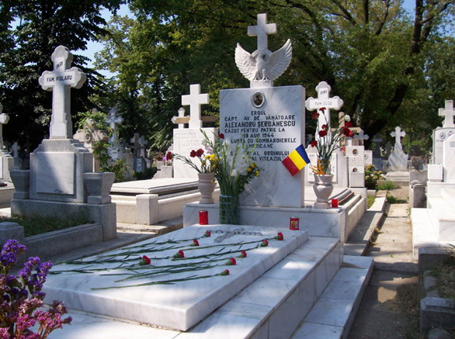
The tomb of Alexandru Serbanescu
The text reads: Hero cpt. av. fighter Alexandru Serbanescu fallen for the motherland on 18 August 1944, in battle with the American bombers - Knight of the "Mihai Viteazul" Order

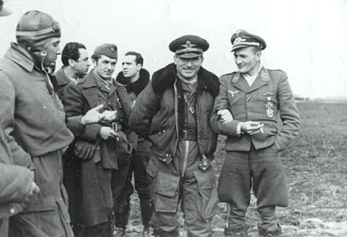
Cpt. av. Alexandru Serbanescu is the second from the right in this photo.
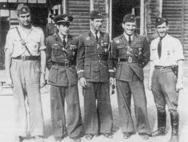
Cpt. av. Alexandru Serbanescu is the second from the right in this photo.

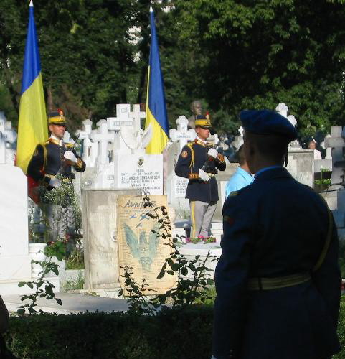
Soldiers of the 30th Guard Regiment by his tomb during the ceremony comemorating 60 years since he was killed in aciton
Lt. J.R.Busley from 309sq, 31FG shot down Cpt.Alexandru Serbanescu ( with a faulty radio) on 18 august '44 .
A short combat biography of the american pilot John R.Busley still the one who made Cpt. Alexandru Serbanescu an HERO.
John R.Busley 309sq, 31FG -total credited victories -3 .
- 1st april’44, Lt. John R. Busley arrived at San Severo (20miles N of Foggia) as a replacement pilot in 309sq, 31FG.
-21st april’44 in a mission to Ploesti, Lt. Busley claimed as probably victory a Reggiane 2001 ( latest reserch reveal that it was a german BF 109/JG 77 with rocket tubes underwing).
- 5 july ’44, Lt.Busley finished the RAF gunnery school in Cairo and was promoted 1st Lieutenant.
- 11 july ‘44, 1st Lt.Busley volunteering accept extra duty as Armaments Officer.
- 6 august’44, on a escort mission to Lyon France, Busley shot down unindentified twin engine fighter ( Me 410?)
- 18 august ’44, on escort mission to Ploesti , Busley was credited with a Bf-109.
- 8 sepember’44, Lt.Busley with Lt.Boudra after a escort mission for three C-47 to Popesti Leordeni, spent one night in Bucharest ( because of mechanic failures of the Mustangs).
-10 october ’44, Busley was promoted Captain.
- 7 november’44, Cpt.John R.Busley finished the combat tour and get back to U.S. ( interior zone activity ).

“1 Yellow”
The model is a Revell Me-109G4, upgrade to G6. I changed the upper engine cowling , added machine guns bulges, interior and exterior set from Eduard, the HGW belts, decals from Techmod for " Michael’cross" and Radu Branzan for group mark "Desloch-Serbanescu" . Paints from Gunze and ModelMaster. I worked as color profile from the book "ROMANIAN FIGHTER COLORS 1941-1945."Hope you enjoy!

“1 White”
The second model is also a Serbanescu Me-109 flew in 1943 in Russia, an G2. This model is Revell ,made by my friend Valy also in memory of Serbanescu. This model is made out of the box with small improvements.

